Computer Science 4602
Fall 2020
Quiz 2

1. Draw a state transition diagram of a FSM that decides language $A=\{"\text{ab"}\}$ over alphabet $\{a,b\}$. There is only one string in $A$. Be sure to mark the start state and accepting states. Be sure there is a transition out of every state for every symbol in the alphabet.

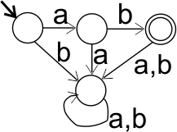

2. Draw a state transition diagram of a FSM that decides language B = {$x ∈ {\left\{a,b\right\}}^{*} | \left|x\right| ≥2$ and the next-to-last symbol in $x$ is $a$} Some of the strings in B are $"aa"$, $"bab"$, $"bbaab"$ and $"abaaa"$. Be sure to mark the start state and accepting states.

Hint. Have a state for each pair of symbols that might be the last two in a string. The state for strings that end on $bb$ can serve as a start state.

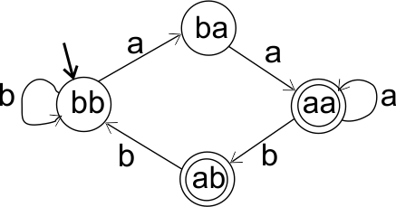
3. Prove that language $C=\left\{a^{n}b^{2n} \right| n>0\}$ over alphabet $\{a,b\}$ is not regular. Make your proof clear and readable, but not verbose. Do not expect the reader to guess what you are doing.

Theorem. C is not regular.
Proof. By contradiction. Assume that C is regular. Let M be a FSM that solves C.

Perform an experiment where we run M on strings of the form $a^{k}$ and record, for each, the state that M reaches on that string. Because M has finitely many states, we must eventually find two strings $a^{m}$ and $a^{n}$ that cause M to end on the same state q.

Let q’ be the state that M reaches if it is started in state q and reads $b^{2m}$. Because $a^{m}$ and $a^{n}$ both take M to state q, strings $a^{m}b^{2m}$ and $a^{n}b^{2m}$ both take M to state q’. Those observations are captured in the following picture.

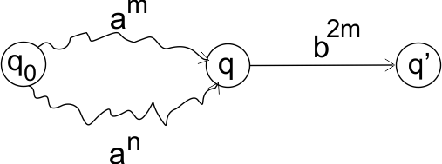

Since $a^{m}b^{2m}∈C$, q’ must be an accepting state. Since $a^{n}b^{2m}∉C$, q’ must be a rejecting state. But q’ cannot be both an acception state and a rejecting state. That is a contradiction.

