Library study rooms:

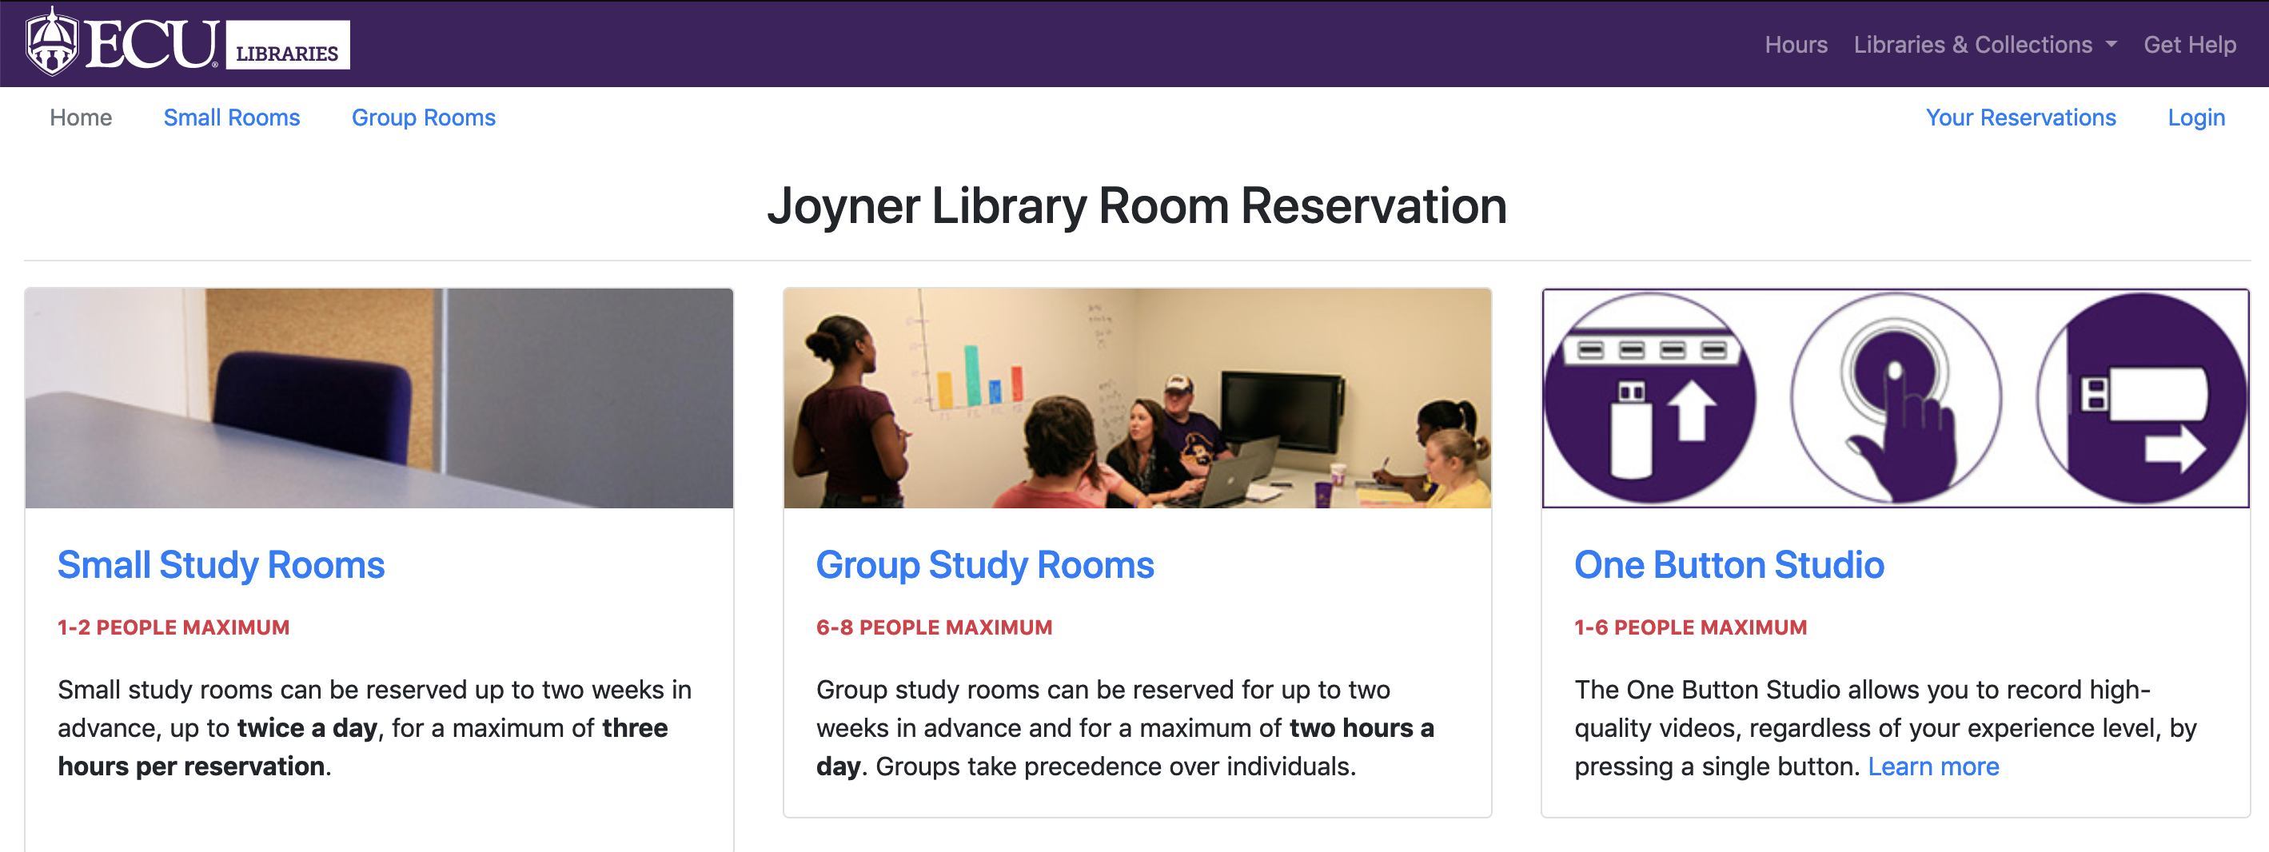

This short video shows a library computer lab and group workspaces:
https://www.youtube.com/watch?v=3dw0Yq-N_v0

This video shows the library workspaces as well:
https://www.youtube.com/watch?v=4VQwDCMT_gM

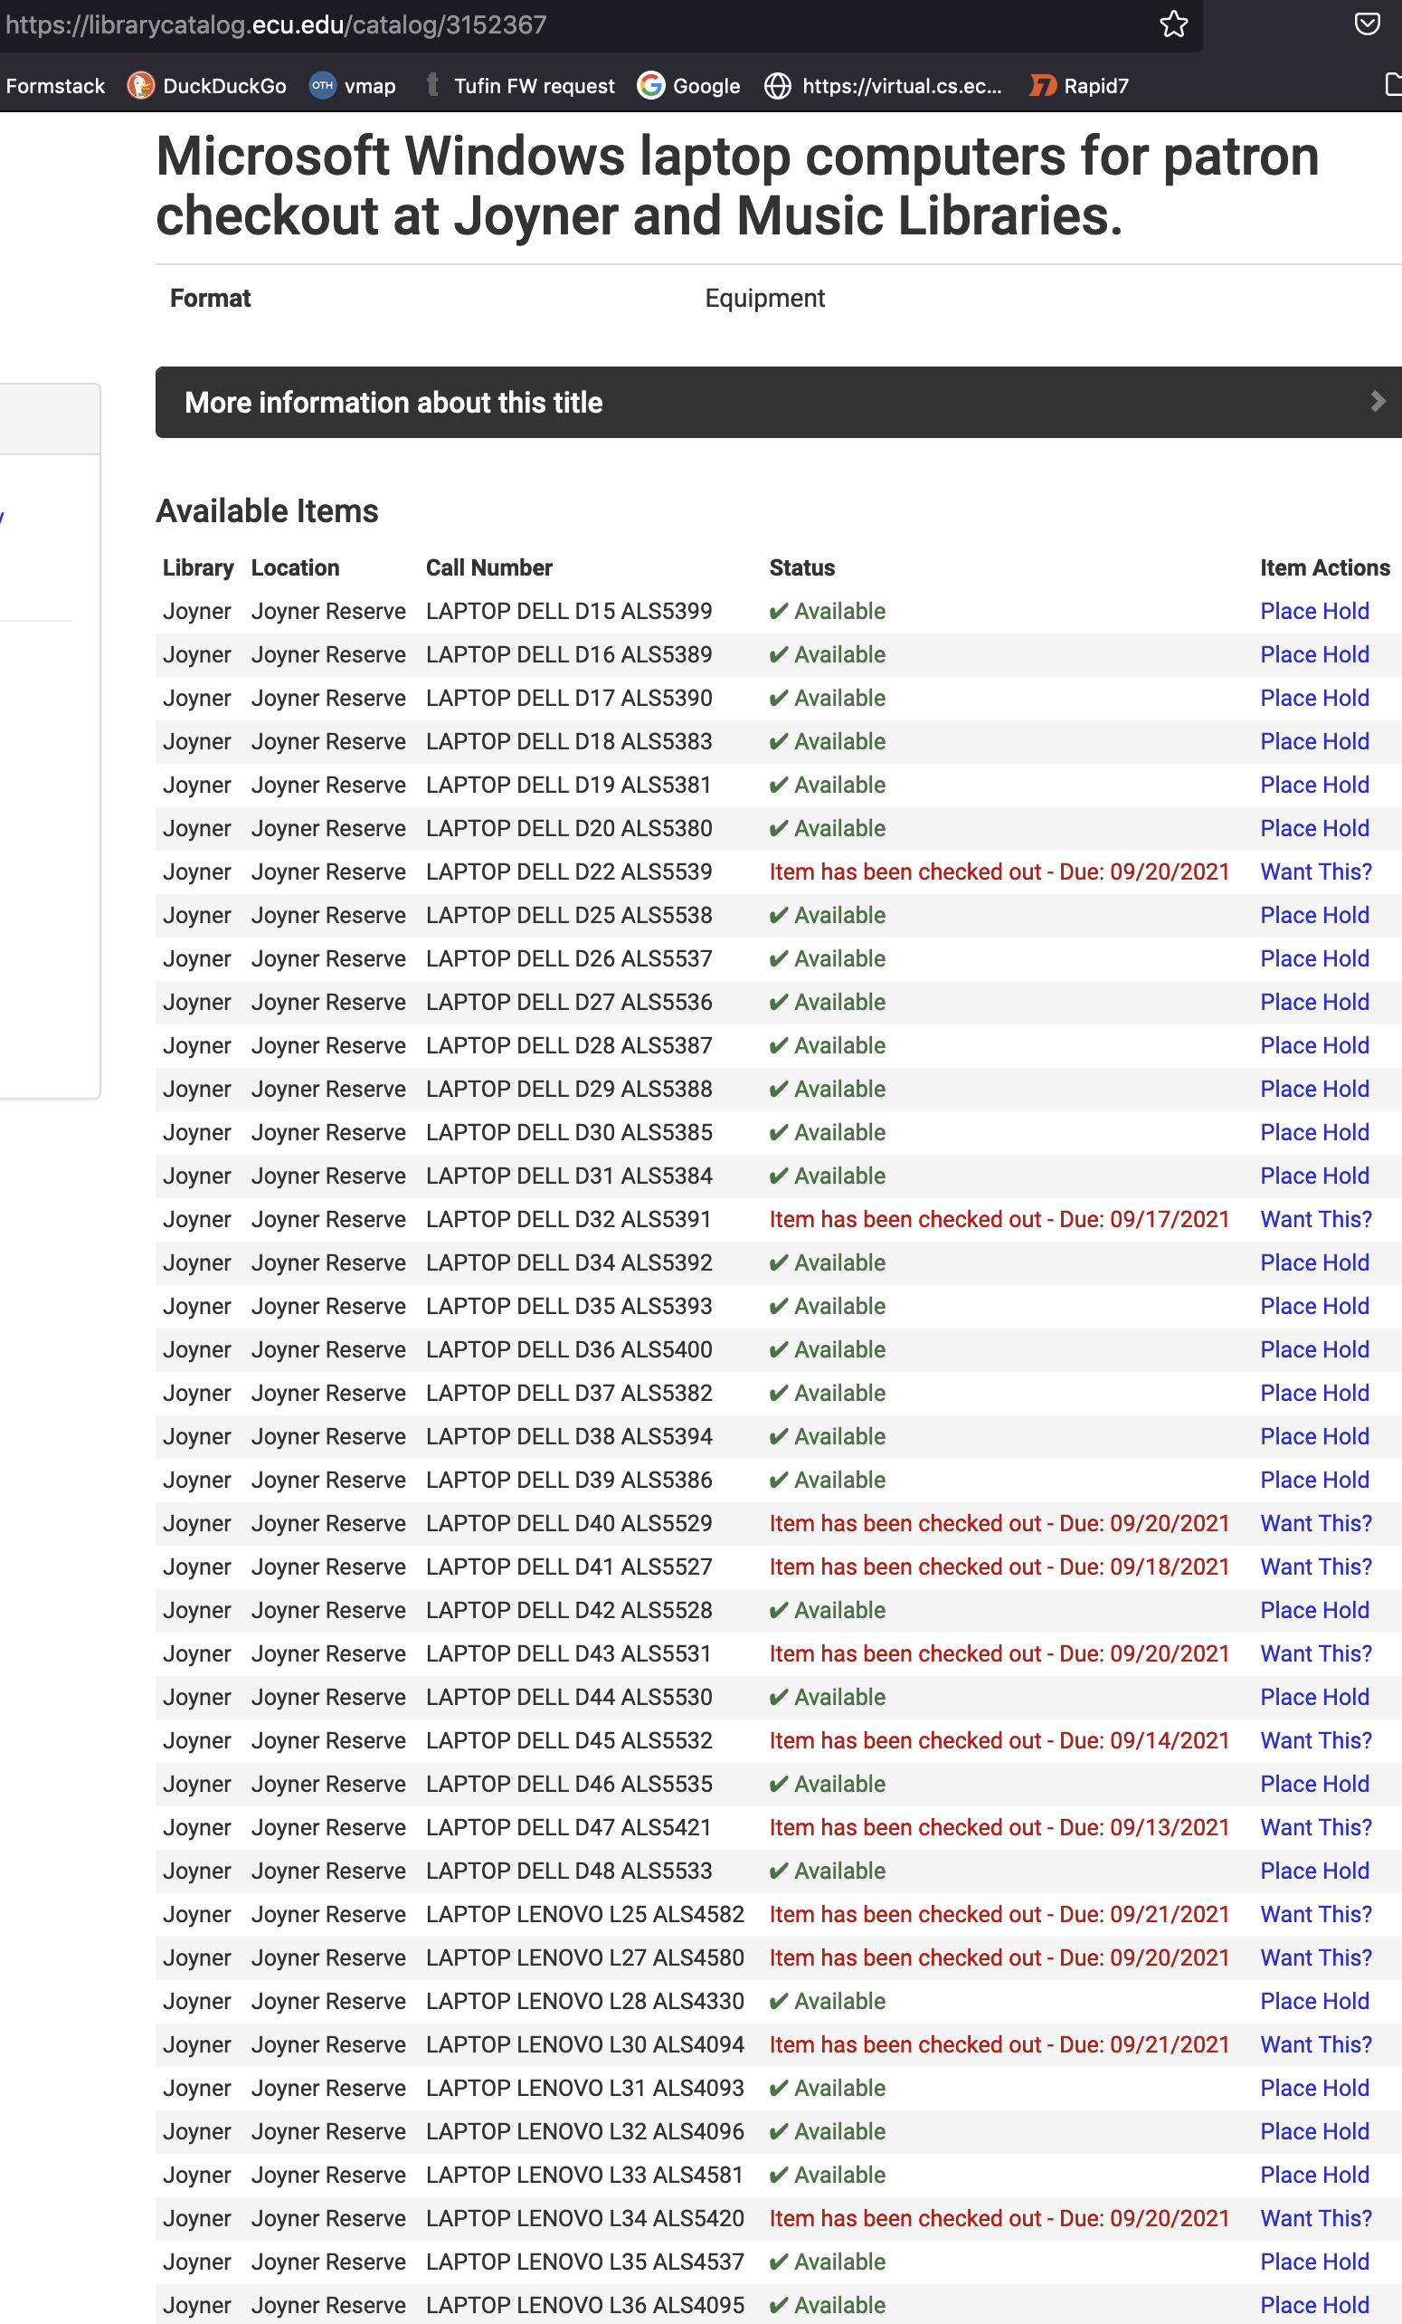
A partial list of all computers available for loan from the library is shown above.

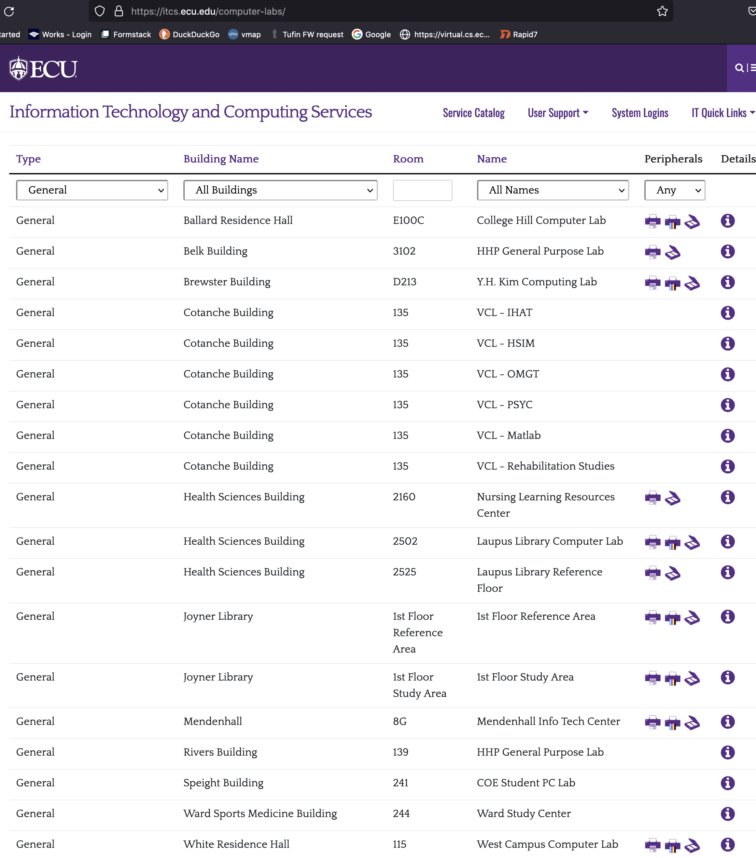
A partial list of open computer labs available to all students is shown above.

