
User Manual
for

AutoMac Banking System
Document Version <1.0>

Prepared by
Group Name: AutoMac – Group 4
Ramon C. Tiongson Jr. | 0463421 | tiongsr@mcmaster.ca
Belal Abu Shaar | 0450237 | aboushba@mcmaster.ca
Monica Jain | 0571252 | Jainm4@mcmaster.ca

Instructor: | Dr. K. Sartipi
Course: | Software Engineering 3MO4
Lab Section: | L02
Teaching Assistant: | Min Shen  Anis Yousefi
Date: | Oct-23-2007

Contents

Contents 2
Introduction 3
Purpose 3
System Overview 3
Definitions, Acronyms and Abbreviations 4
Function of the ABM Machine 5
INFORMATION FOR OPERATOR 11
Appendix A – Group Log 13

Introduction
This document describes has a complete user manual of Automated Banking Machine system (ABM). The purpose of this document to familiarize the user with the function of ABM machine.

Purpose
This document's purpose is to provide to help the user to use ABM machine. It also provides the system overview and helps user to understand the function of the machine.

System Overview

ABM allows clients to obtain cash or a cash advance using their banking, credit or charge card from any Automated Banking Machine (ABM) not belonging to their financial institution, 24 hours a day, seven days a week. They can do transactions like deposit, withdrawal, transfer of funds and payment of bills.
As the client uses the ABM access card the ABM will request for a PIN. From the information on the magnetic stripe, the Acquirer determines who issued the card and sends a message requesting authorization for the transaction. The message goes through the AutoMac Banking Machine Network to be approved by the Issuer. At the necessary moment the system will inform the bank staff if there is a shortage of funds only if the funds are below $10,000. The technical difficulties like system crash; security etc. will be maintained by the Bank staff. Once the transaction is approved, the funds are dispensed by the ABM and a printed record of the transaction is made available. The cardholder retrieves their banking card and the printed record of the transaction. The overview of the whole system is shown below.

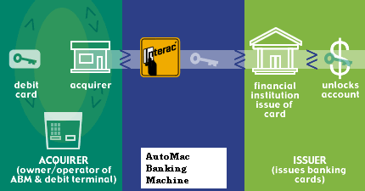

Definitions, Acronyms and Abbreviations
ABM – Automated Banking Machine
AMBM – AutoMac Banking Machine
RFP – Request for Proposal
SRS – Software Requirements Specification
UI – User Interface

Document Overview

In the following part there is step by step instruction of how to use ABM software.

Function of the ABM Machine
Here is the step by step instruction to use ABM Machine effectively.

1.The Machine asks user to swipe the card in order to make the transactions. Swipe the card through the dark slot, otherwise it’s a bad card swipe.
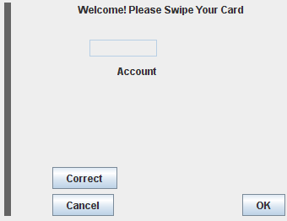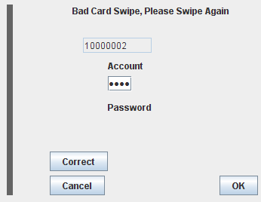

Figure (a)
2. Swipe your card and enter the Pin Number after swiping the card (fig a)
3. Please enter the correct PIN. Entering the wrong PIN three times will lock your account, and you will have to contact your bank administration to reset it.

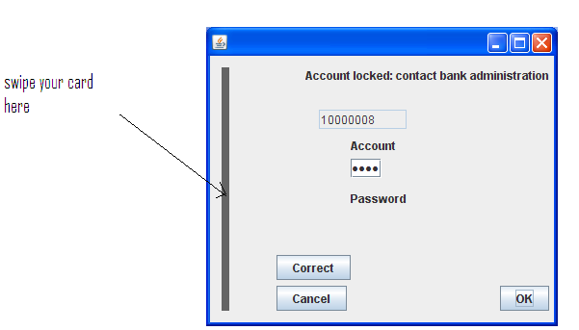
Figure (b)

TRANSACTION

- Select the transaction type (figure c)
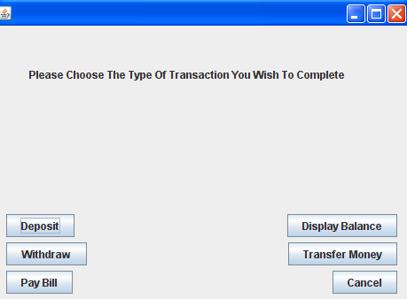
Figure (c)

- After selecting the transaction type, select the Account type (saving/chequing) (figure D)

Figure (d)

Withdrawal
- Select Withdraw
- Enter the withdrawal amount by pressing other / select the withdrawal amount(figure e)
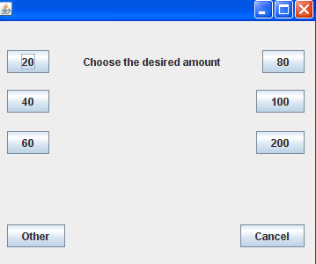
Fig(e)

- Hit OK to confirm or press cancel to cancel the amount.
- After hitting OK wait for the receipt
- Click on Remove Receipt and the Receipt of all the transactions done is printed. (figure f)

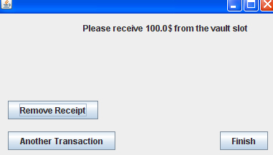
Figure (f)

THE RECEIPT PRINTED
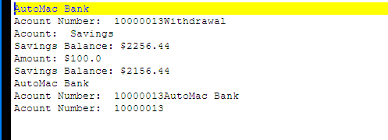

Deposit

  - Click on Deposit
  - Enter the amount to be deposited(figure G)
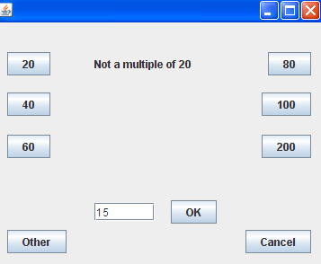

Figure (g)
  - Hit OK to confirm or press cancel to cancel the amount.
  - After hitting OK wait for the receipt
  - Click on remove receipt after the receipt is printed

Transfer

- Select Transfer and select the account type
- Enter the amount to be transferred.(figure h)
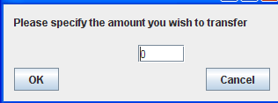
Figure(h)

- Hit OK to confirm or press cancel to cancel the amount. (figure I)
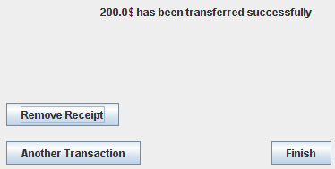
Figure (I)

- After hitting Remove Receipt wait for the receipt
- Receipt is printed

Pay Bills

- Select Pay Bills and Select the account Type
- Select the bills to be paid on the screen (figure J)
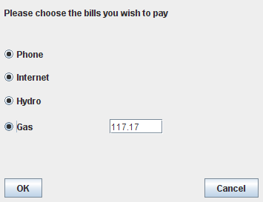
Figure J

- Hit OK to confirm or press cancel to cancel the amount.
- After hitting Remove Receipt wait for the receipt
- Receipt is printed

INFORMATION FOR OPERATOR
Operator related requirements

- The ABM will have a key-operated switch that will allow an operator to start and stop the servicing of customers
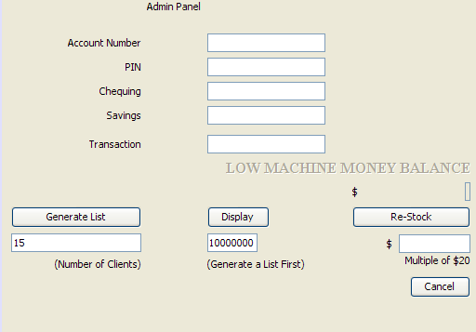
Figure (k)
after turning the switch to the ON position, the operator will be required to verify and enter the total cash in stock.

The machine can only be turned off when it is not servicing a customer

When the switch is moved to the OFF position, the machine will shut down, so that the operator may remove deposited envelopes and reload the machine with cash, blank receipts, etc.(figure K)

Incorrect tries: the numbe3r of times the PIN was not entered correctly in the past 24 hrs is 3. Figure (L)
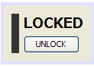
Figure (L)
Card status flag: can be 0 for “card disabled” or 1 for “card active”

List of accounts linked to the card:
- account number: 12 numeric digits.
- Account identifier: Chequing: 0, Savings: 1, Credit Card: 2
- Account Balance: regular balance plus any amounts that are still on hold.

- Amounts deposited in cheques will be on hold for three days. At the end of that period the bank shall either receive a confirmation regarding the cheque validity, or it shall inform the client that the cheque has been returned, and the cheuqe amount will not be debited to the client’s account.
- MacBank Information Technology System is responsible for monitoring the hold amounts, hold times, and updating the central database accordingly.

- A new day starts exactly at 00:00 am
- Mac bank does not communicate with any other banks and serves only MacBank clients.
- PIN authentication is always required. (There is no such thing as – card with a blank PIN number)

- A transaction will be considered complete by the bank once it has been approved.
- In the case of deposit, a second message will be sent to the bank indicating that the customer has deposited the envelope. (if the customer fails to deposit the envelope within the timeout period, or presses cancel instead, no second message will be sent to the bank and the deposit will not be credited to the customer.)

- the ABM will provide the customer with a printed receipt for each successful transaction, showing the date, time, type of transaction, account(s), amount, and ending and available balance(s) of the affected account (“to” account for transfers)
- Minimum money in the ABS is $10,000 before it flags the operator.
- There is no limitation for maximum amount of money in the ABM.

- IF the customer has been inactive for 30 seconds the entire session shall be terminated.
- The ABM can be stocked with only 20-dollar bills. When restocking the machine, the operator has to indicate many 20-dollar bills have been stocked.

- The ABM has NO fake bill-detector and it cannot exchange foreign currency.
- Machine never has zero money.

Appendix A – Group Log
November 24, 2007

The user manual was created by Monica, Ramon and Bilal.

1.Last discussion on ABM system
2.Testing
3.Including the details in User Manual

