ABM User Guide
November 27, 2007

Prepared by The ABM Group:
Amer El-Kalache | 0543480 | elkalaa@mcmaster.ca
Bahy Mehany | 0552303 | mehanyb@mcmaster.ca
Mohamed Ismail | 0546901 | ismaim@mcmaster.ca

Table of Contents

1.0 Overview 3
Purpose 3
How to Use This Document 3
Assumptions 3
2.0 Transactions (MacBank Customers) 4
2.1 Withdrawal 7
2.2 Deposit 11
2.3 Transfer 12
2.4 View Balance 13
2.0 Maintenance (MacBank Staff) 14
3.0 Troubleshooting (Error Messages) 16

Table of Figures
Figure 1: Welcome Screen 4
Figure 2: PIN Verification Screen 5
Figure 3: Transaction Selection Screen 6
Figure 4: Account Selection Screen 7
Figure 5: Amount Selection Screen 8
Figure 6: Enter Amount Screen 9
Figure 7: Transaction Complete Screen 10
Figure 8: Print and Exit Screen 11
Figure 9: Account Selection Screen 12
Figure 10: View Balance Screen 14
Figure 11: Maintenance Screen 15
Figure 12: Enter Restock Amount Screen 16

Overview

Purpose
This document provides the operational manual for the MacBank ABM on Windows Operating systems.

How to Use This Document
The information in this user guide, as outlined in the table of contents, is divided into sections corresponding to the type of user.
The users are :
- MacBank Customers
- MacBank Staff

Assumptions
- The ABM will contain $20,000 in initial stock
- Anyone using the bank machine can follow basic instructions
- Only the bank staff have the maintenance key

Transactions (MacBank Customers)
The welcome screen of the ABM is shown in Figure 1.
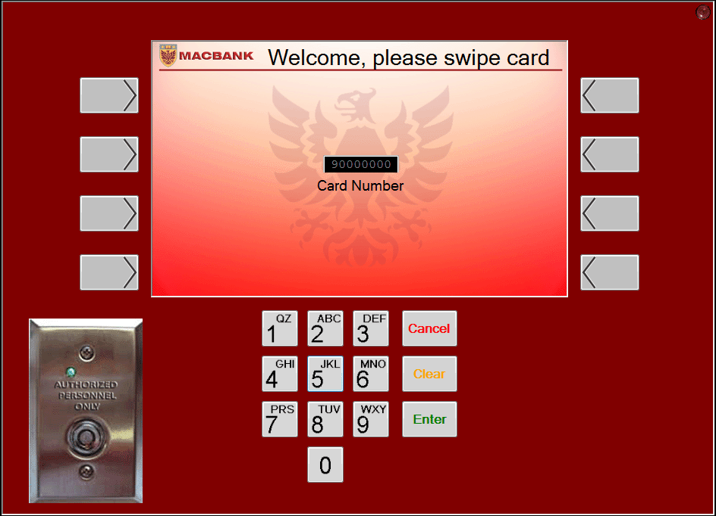
Figure 1: Welcome Screen
- Swipe Card and the card number will appear in the card number box
- To cancel, press the ‘Cancel’ button
- To continue, press ’Enter’
- Card number will be verified with the database

The PIN Verification Screen of the ABM is shown in Figure 2.
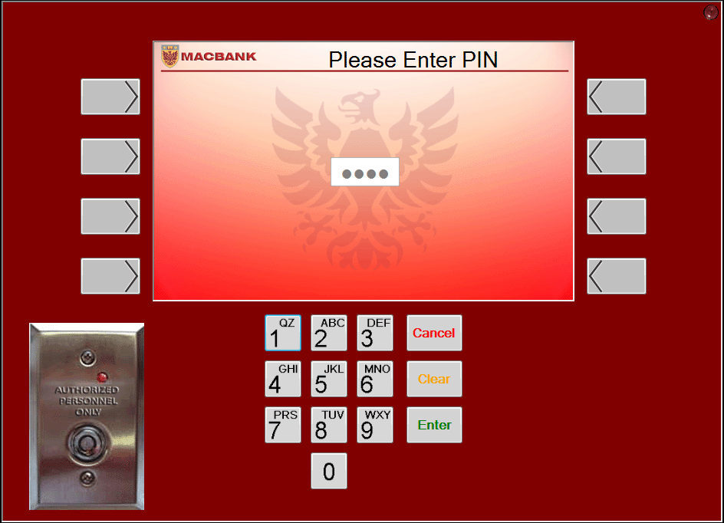
Figure 2: PIN Verification Screen
- Enter 4-digit PIN using keypad. PIN is displayed as per Figure 2
- If PIN is entered incorrectly, press ‘Clear’ to re-enter PIN
- To continue, press ‘Enter’
- PIN will be verified with the database with respect to the card number
- Remember to protect your PIN from others
- To exit at any time, press ‘Cancel’

The Transaction Selection Screen of the ABM is shown in Figure 3.
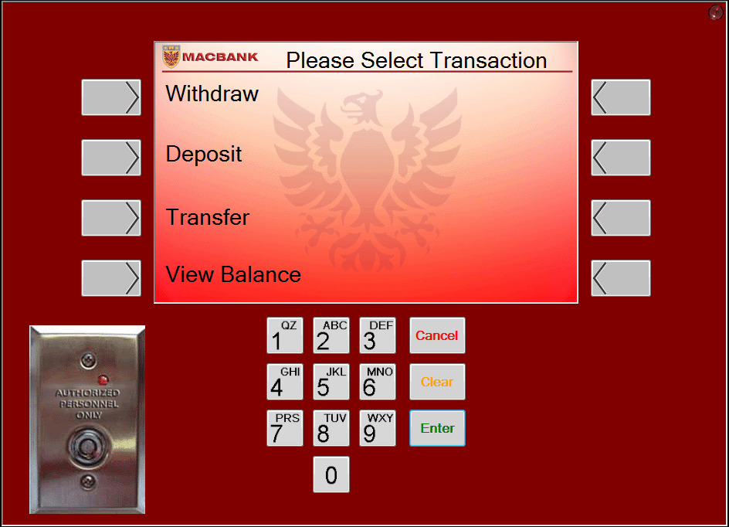
Figure 3: Transaction Selection Screen
- Use left selection keys to choose transaction
- To exit at any time, press ‘Cancel’

Withdrawal
After selecting withdrawal, The Account Selection Screen of the ABM will appear as in Figure 4.
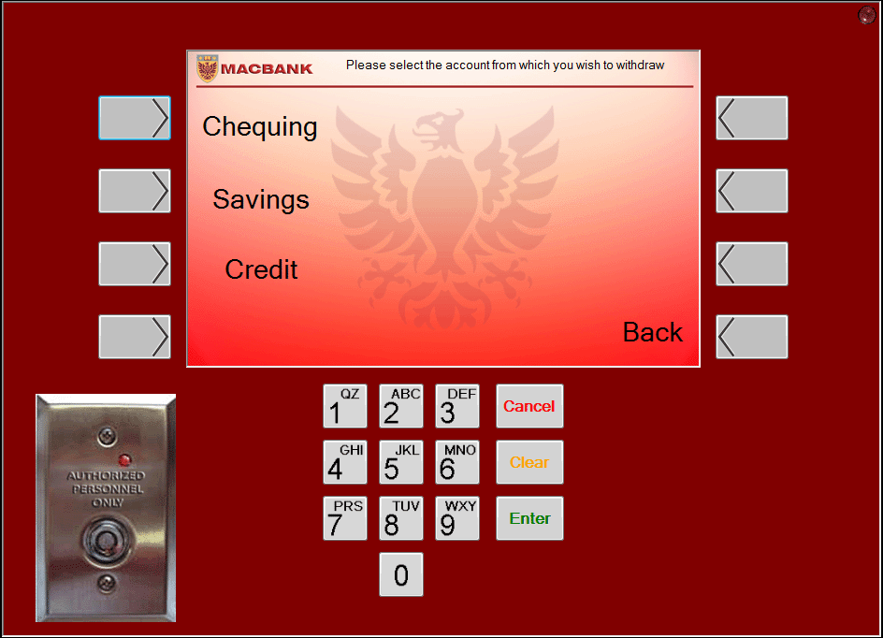
Figure 4: Account Selection Screen
- Use left selection keys to select the account you wish to withdraw from
- Select ‘Back’ to return to transaction selection screen
- To exit at any time, press ‘Cancel’

After selecting an account, The Amount Selection Screen of the ABM will appear as in Figure 5.
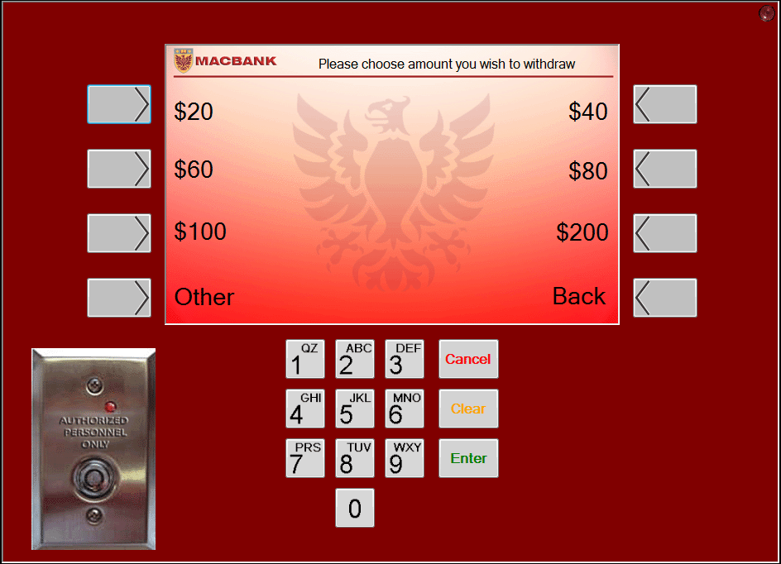
Figure 5: Amount Selection Screen
- Use top 3 left and right selection keys to select amount you wish to withdraw
- If amount does not exist, select ‘Other’
- Select ‘Back’ to return to transaction selection screen
- To exit at any time, press ‘Cancel’

If ‘other’ was selected, The Enter Amount Screen of the ABM will appear as in Figure 6.
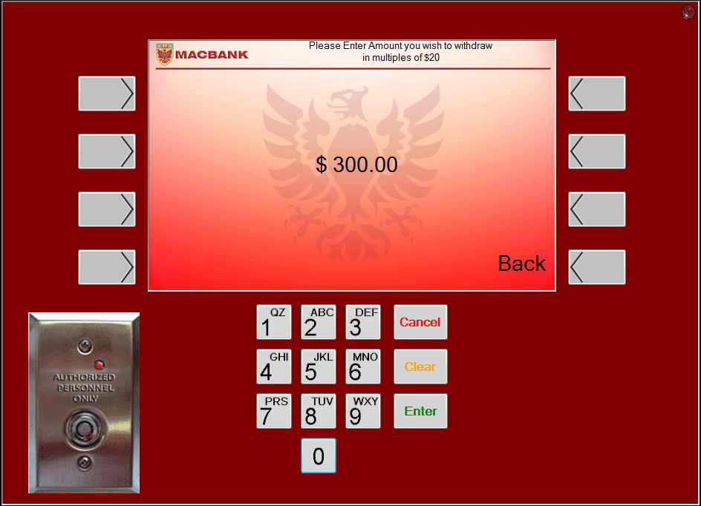
Figure 6: Enter Amount Screen
- Use keypad to enter the amount you wish to withdraw in multiples of $20 up to $500
- If amount is entered incorrectly, press clear to re-enter amount
- Select ‘Enter’ to proceed
- Select ‘Back’ to return to transaction selection screen
- To exit at any time, press ‘Cancel’

If transaction is completed, The Transaction Complete Screen of the ABM will appear as in Figure 7.
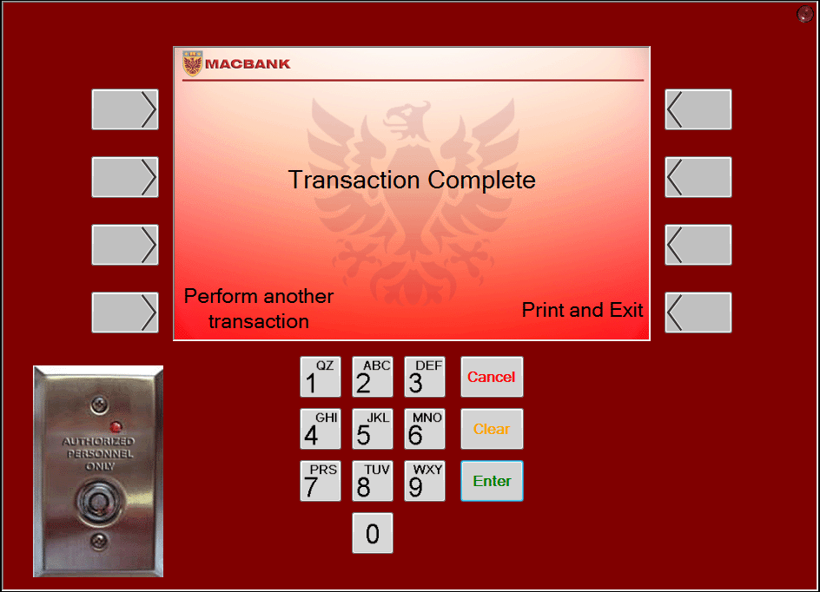
Figure 7: Transaction Complete Screen
- Select ‘Perform another transaction’ if you wish to perform another transaction
- Select ‘Print and Exit’ to print and exit

While printing is in progress, The Print and Exit Screen of the ABM will appear as in Figure 8.
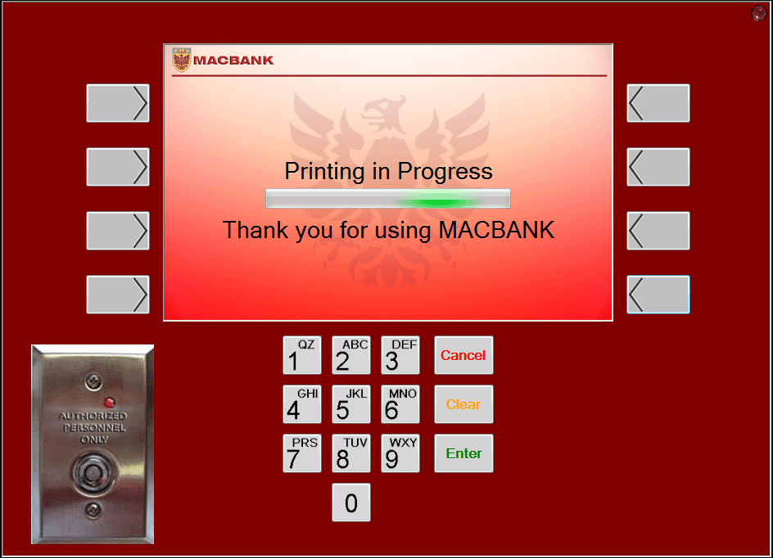
Figure 8: Print and Exit Screen
- Remove receipt
- You will be redirected to the welcome screen

Deposit
After selecting Deposit, the Account Selection Screen of the ABM will appear as in Figure 4 above.
- Use left selection keys to select the account you wish to deposit to
- Select ‘Back’ to return to transaction selection screen
- To exit at any time, press ‘Cancel’

After selecting an account, The Enter Amount Screen of the ABM will appear as in Figure 6 above.
- Use keypad to enter the amount you wish to deposit
- If amount is entered incorrectly, press clear to re-enter amount
- Select ‘Back’ to return to transaction selection screen
- To exit at any time, press ‘Cancel’
If transaction is completed, The Transaction Complete Screen of the ABM will appear as in Figure 7 above.
- Select ‘Perform another transaction’ if you wish to perform another transaction
- Select ‘Print and exit’ to print and exit

While printing is in progress, The Print and Exit Screen of the ABM will appear as in Figure 8 above.
- Remove receipt
- You will be redirected to the welcome screen

Transfer
After selecting Transfer, the Account Selection Screen of the ABM will appear as in Figure 9.
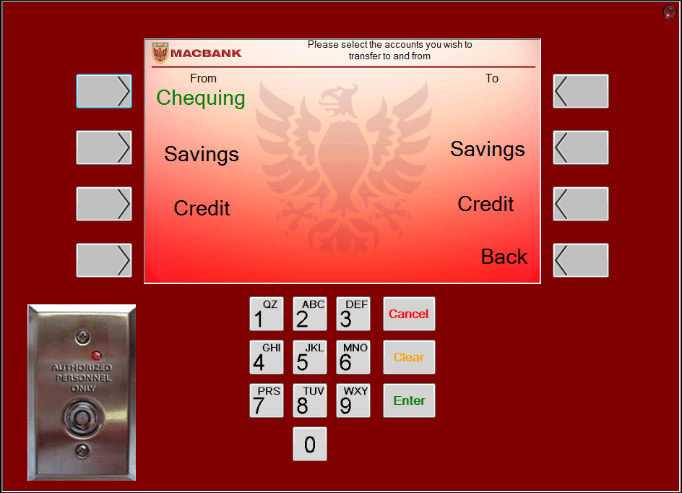
Figure 9: Account Selection Screen
- Use left selection keys to select the account you wish to transfer from
- Use right selection keys to select the account you wish to transfer to
- You may not select the same account twice
- Select ‘Back’ to return to transaction selection screen
- To exit at any time, press ‘Cancel’

After selecting the accounts, The Enter Amount Screen of the ABM will appear as in Figure 6 above.
- Use keypad to enter the amount you wish to transfer
- If amount is entered incorrectly, press clear to re-enter amount
- Select ‘Back’ to return to transaction selection screen
- To exit at any time, press ‘Cancel’
If transaction is completed, The Transaction Complete Screen of the ABM will appear as in Figure 7 above.
- Select ‘Perform another transaction’ if you wish to perform another transaction
- Select ‘Print and exit’ to print and exit

While printing is in progress, The Print and Exit Screen of the ABM will appear as in Figure 8 above.
- Remove receipt
- You will be redirected to the welcome screen

View Balance
After selecting View balance, the Account Selection Screen of the ABM will appear as in Figure 4 above.
- Use left selection keys to select the account you wish to view
- Select ‘Back’ to return to transaction selection screen
- To exit at any time, press ‘Cancel’

After selecting an account, the View Balance Screen of the ABM will appear as in Figure 10.
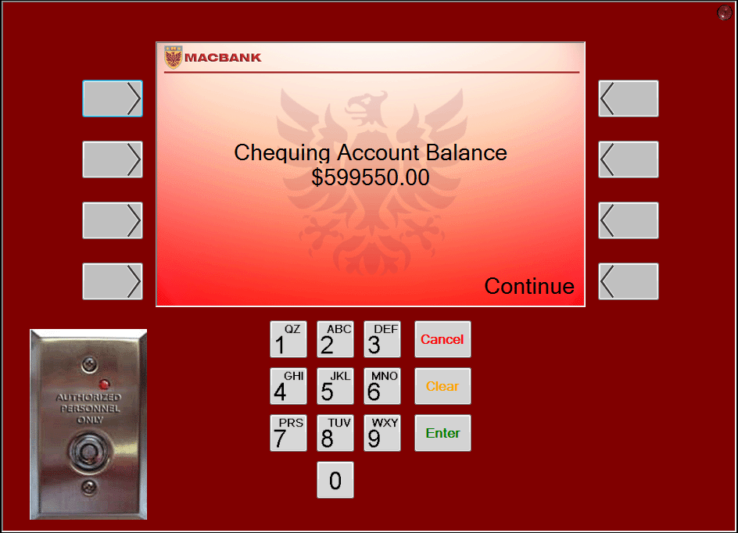
Figure 10: View Balance Screen
- Press ‘Continue’ to proceed
- To exit at any time, press ‘Cancel’

If ‘Continue’ is selected, The Transaction Complete Screen of the ABM will appear as in Figure 7 above.
- Select ‘Perform another transaction’ if you wish to perform another transaction
- Select ‘Print and exit’ to print and exit

While printing is in progress, The Print and Exit Screen of the ABM will appear as in Figure 8 above.
- Remove receipt

Maintenance (MacBank Staff)
The welcome screen of the ABM is shown in Figure 1 above.
- Insert key into key switch
If key is entered into key switch, the Maintenance Screen of the ABM will appear as in Figure 11.
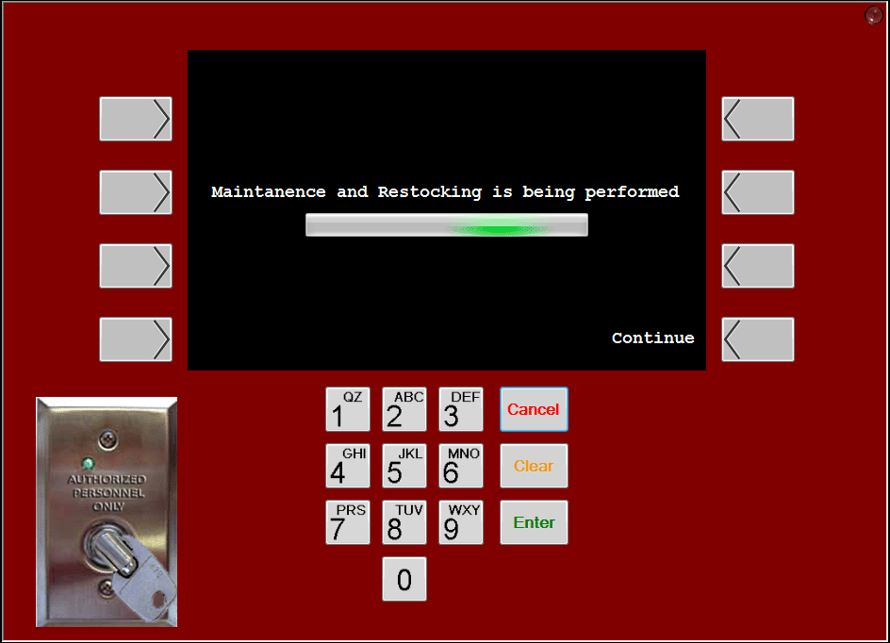
Figure 11: Maintenance Screen
- Perform required maintenance and restocking operations
- Select ‘Continue’

When ‘Continue’ is selected, the Enter Restock Amount Screen of the ABM will appear as in Figure 12.
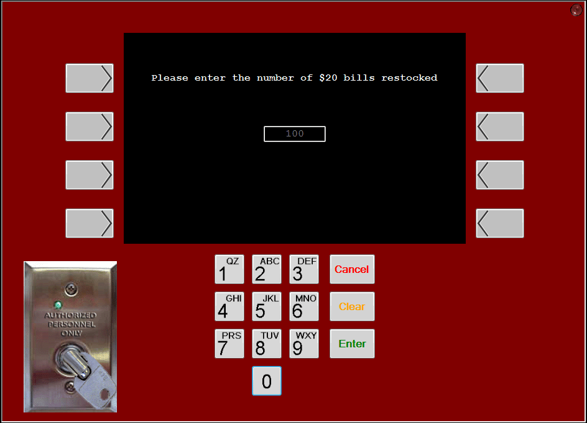
Figure 12: Enter Restock Amount Screen
- Enter the restock amount
- If amount is entered incorrectly, press clear to re-enter amount
- To exit at any time, press ‘Cancel’
- When operation is complete, remove key from switch

Troubleshooting (Error Messages)
“Card Read Error. Please swipe again.”
- Card was either swiped incorrectly, or the card is not a valid MacBank card
- Re-swipe card or use a proper card
“Invalid PIN. Please Re-enter”
- PIN does not match the account number
- Re-enter the correct PIN
“Account does not exist”
- The user does not have this type of account
- Select a different type of account
“Insufficient Funds”
- The account does not have the necessary funds for the transaction
- Select a different amount or account
- To view balance, refer to 2.4
“Please enter amount in multiples of $20”
- The amount entered must be in multiples of $20 for withdrawal
- Select a different amount to withdraw in multiples of $20
“Please enter an amount”
- No amount was entered
- Use keypad to enter an amount

