Cruise Control System
SFWR ENG 3KO4 (Software Development), McMaster University
Instructor: Dr. Kamran Sartipi
By: Naser Faramarzpour (TA)

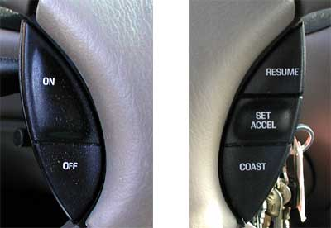

Design the component diagram and statechart(s) for a cruise control system of an
automobile with the following specifications:

- Cruise control system has an on/off button that activate/deactivate cruise system.
- Cruise control is disabled, after: i) on/off button is set to on,
ii) cancel button is pressed; or iii) brake pedal is pressed.
- Cruise system will be enabled by pressing set or resume button.
- When system is enabled, it will maintain the speed of the car at the cruise speed.
- Cruise speed will be set to the car speed if cruise is enabled by the set button.
- When set button is pushed, the cruise speed will also be memorized.
- Cruise speed will be loaded from the memory, if cruise is enabled by the resume button.
- When cruise is enabled, accelerate pedal will bring the speed of the car up, but it will go down back to the cruise speed, when the pedal is released.
- When cruise is enabled, cruise speed can be adjusted by accelerate (up), and coast (down) buttons.
- Cruise speed can not be set below 40Km/h.

Component Diagram:

State Charts:

